**FCFS**

**Program**

#include<stdio.h>

int head,a[20],i,distance,n,seektime;

int main()

{

printf("\nEnter Head position:");

scanf("%d",&head);

printf("\nEnter number of disk requests:");

scanf("%d",&n);

printf("\nEnter the disk requests:");

for(i=1; i<=n; i++)

scanf("%d",&a[i]);

a[0]=head;

printf("*********FCFS DISK SCHEDULING*********\n");

for(i=0;i<n;i++)

{

distance=(a[i]>a[i+1])?a[i]-a[i+1]:a[i+1]-a[i];

printf("Head movement from %d to %d : %d\n",a[i],a[i+1],distance);

seektime=seektime+distance;

}

printf("Total seek time is : %d\n",seektime);

}

**Output**

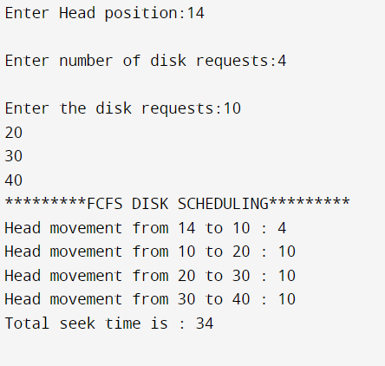

**C SCAN**

**Program**

#include<stdio.h>

#include<stdlib.h>

int main()

{

int RQ[100],i,j,n,TotalHeadMoment=0,initial,size,move;

printf("Enter the number of Requests\n");

scanf("%d",&n);

printf("Enter the Requests sequence:\n");

for(i=0;i<n;i++)

scanf("%d",&RQ[i]);

printf("Enter initial head position:\n");

scanf("%d",&initial);

printf("Enter total disk size:\n");

scanf("%d",&size);

printf("Enter the head movement direction for high 1 and for low 0\n:");

scanf("%d",&move);

for(i=0;i<n;i++)

{

for( j=0;j<n-i-1;j++)

{

if(RQ[j]>RQ[j+1])

{

int temp;

temp=RQ[j];

RQ[j]=RQ[j+1];

RQ[j+1]=temp;

}

}

}

int index;

for(i=0;i<n;i++)

{

if(initial<RQ[i])

{

index=i;

break;

}

}

if(move==1)

{

for(i=index;i<n;i++)

{

TotalHeadMoment=TotalHeadMoment+abs(RQ[i]-initial);

initial=RQ[i];

}

TotalHeadMoment=TotalHeadMoment+abs(size-RQ[i-1]-1);

TotalHeadMoment=TotalHeadMoment+abs(size-1-0);

initial=0;

for( i=0;i<index;i++)

{

TotalHeadMoment=TotalHeadMoment+abs(RQ[i]-initial);

initial=RQ[i];

}

}

else

{

for(i=index-1;i>=0;i--)

{

TotalHeadMoment=TotalHeadMoment+abs(RQ[i]-initial);

initial=RQ[i];

}

TotalHeadMoment=TotalHeadMoment+abs(RQ[i+1]-0);

TotalHeadMoment=TotalHeadMoment+abs(size-1-0);

initial =size-1;

for(i=n-1;i>=index;i--)

{

TotalHeadMoment=TotalHeadMoment+abs(RQ[i]-initial);

initial=RQ[i];

}

}

printf("Total head movement is %d",TotalHeadMoment);

return 0;

}

**Output**

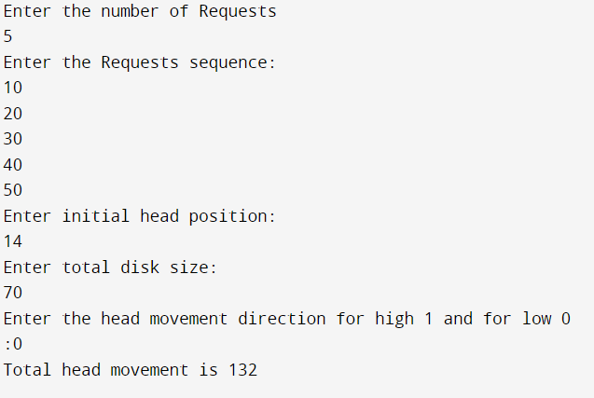

**SCAN**

**Program**

#include<stdio.h>

int absoluteValue(int);

void main()

{

int queue[25],n,headposition,i,j,k,seek=0, maxrange,

difference, temp, queue1[20], queue2[20], temp1=0, temp2=0;

float averageSeekTime;

printf("Enter the maximum range of Disk:" );

scanf("%d", &maxrange);

printf("Enter the number of queue requests:" );

scanf("%d",&n);

printf("Enter the initial head position: ");

scanf("%d", &headposition);

printf("Enter the disk positions to be read(queue): ");

for(i=1;i<=n;i++)

{

scanf("%d",&temp);

if(temp>headposition)

{

queue1[temp1]=temp;

temp1++;

}

else

{

queue2[temp2]=temp;

temp2++;

}

}

for(i=0;i<temp1-1;i++)

{

for(j=i+1;j<temp1;j++)

{

if(queue1[i]>queue1[j])

{

temp=queue1[i];

queue1[i]=queue1[j];

queue1[j]=temp;

}

}

}

for(i=0;i<temp2-1;i++)

{

for(j=i+1;j<temp2;j++)

{

if(queue2[i]<queue2[j])

{

temp=queue2[i];

queue2[i]=queue2[j];

queue2[j]=temp;

}

}

}

for(i=1,j=0;j<temp1;i++,j++)

{

queue[i]=queue1[j];

}

queue[i]=maxrange;

for(i=temp1+2,j=0;j<temp2;i++,j++)

{

queue[i]=queue2[j];

}

queue[i]=0;

queue[0]=headposition;

for(j=0; j<=n; j++)

{

difference = absoluteValue(queue[j+1]-queue[j]);

seek = seek + difference;

printf("Disk head moves from position %d to %d with Seek %d \n",

queue[j], queue[j+1], difference);

}

averageSeekTime = seek/(float)n;

printf("Total Seek Time= %d\n", seek);

printf("Average Seek Time= %f\n", averageSeekTime);

}

int absoluteValue(int x)

{

if(x>0)

{

return x;

}

else

{

return x*-1;

}

}

**Output**

